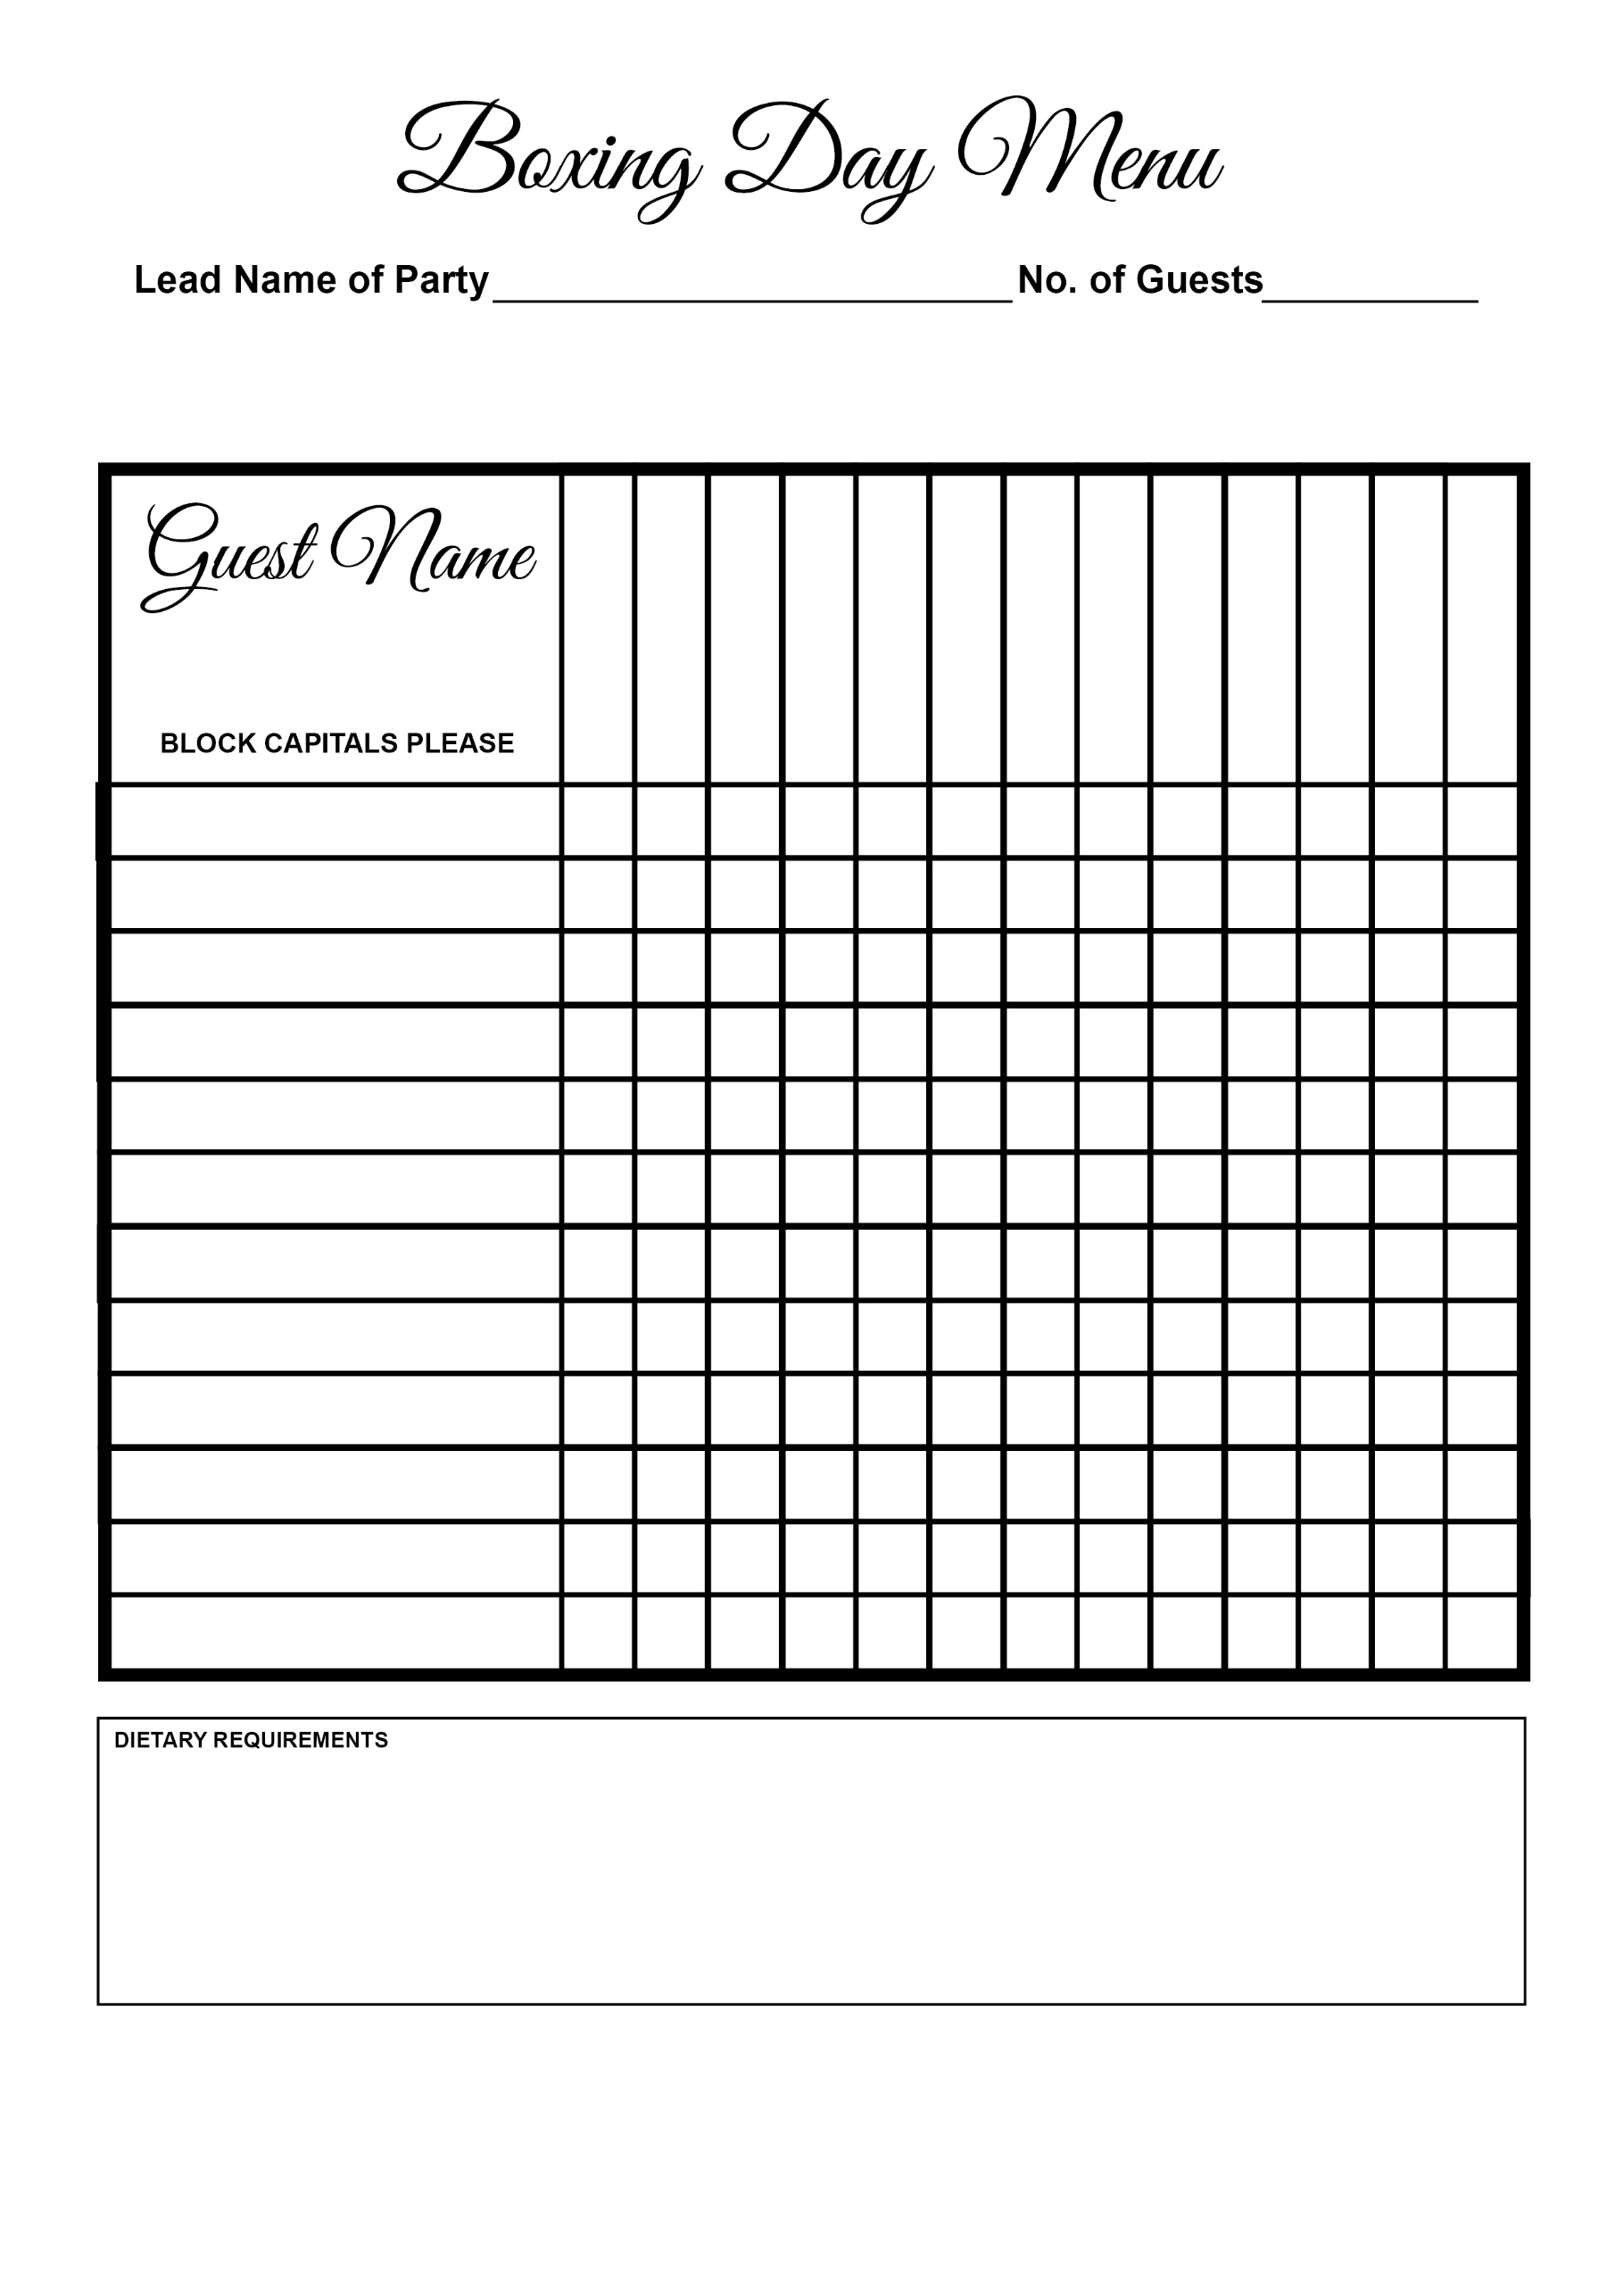



Sticky Toffee Pudding

Goat’s Cheese Tart

Chocolate Parfait

Cheese & Biscuits

Panna Cotta

Lamb

Risotto

Salmon

Chicken

Sea Trout

Game Terrine

Soup