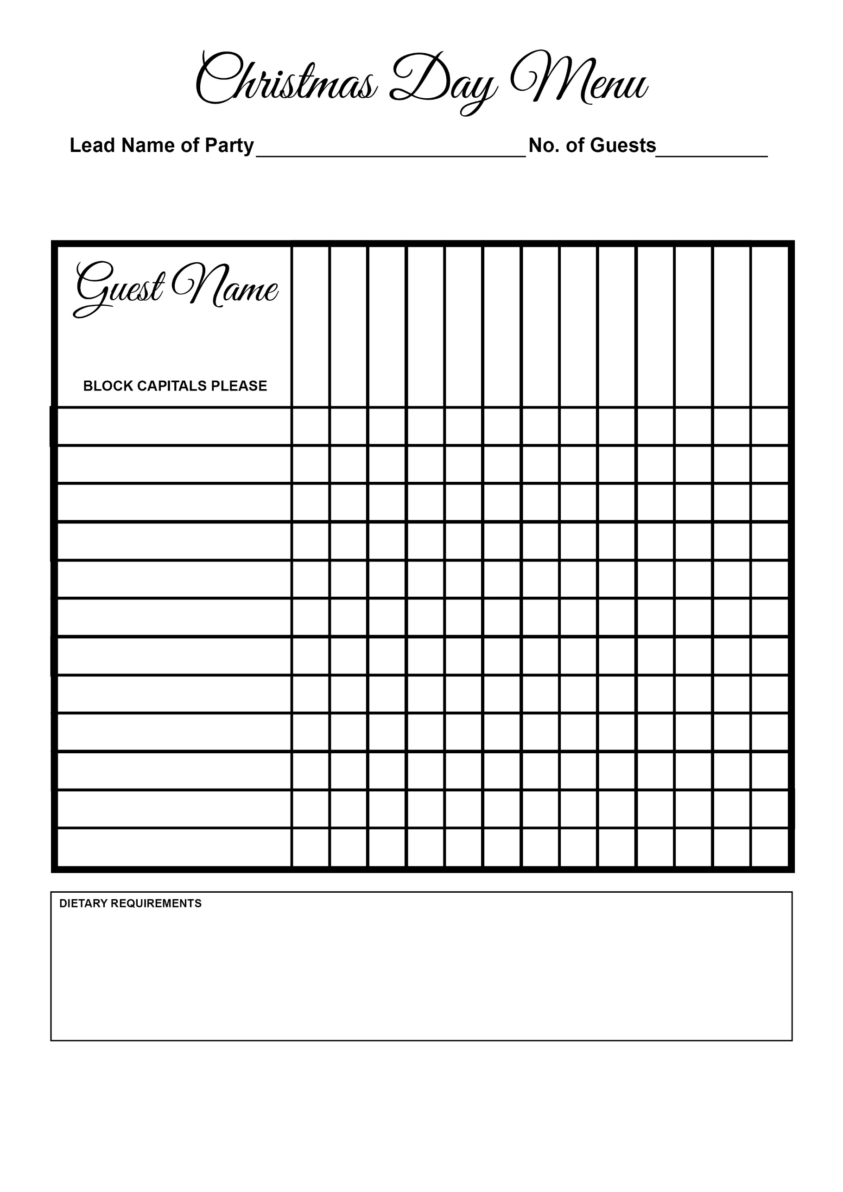

Cheese & Biscuits

Christmas Pudding

Pan Fried Stone Bass

Panna Cotta

Parfait

Risotto

Beef

Turkey

Sorbet

Smoked Salmon

Goat’s Cheese

Terrine

Soup